Chapter 6

FUTURE SCOPE OF ALUMINA & ITS MODIFICATION

Robotics has a very crucial & wide scope in the future as the technology is kissing advancement every single moment to make our life better & more comfortable. Robotics is the present & future of science, a humanoid robot have their own importance because they are design to perform all the task of a human being but in a more precise manner they can perform the task which are nearly impossible for human hands or their strength & speed enables them to perform the task of 10 to 12 humans single handedly & that’s why their bodies are design on the basis of a shape of a human body.

6.1 Generations of Robot:
- First Generation (1960): First generation robot are designed to perform factory work such as performed simple tasks that were dangerous or unpleasant for people. Robots were used to weld, spray paint, move heavy objects, handle hot materials, etc.
- Second Generation (1980): Second generation robot perform more complex task and stimulate many human functions such as sense surroundings and respond to their change in environment.
- Third Generation (1992): On-line computation & controlling, artificial vision, active force/torque interaction with environment.
- Fourth Generation (2000): True android or an artificial biological robot or a super humanoid capable of its own clone.
- Fifth Generation: This generation of robots doesn’t came in play till now, in this type of robot they have artificial intelligence to perform their actions.

New perspectives as compared to the wheeled robots Such as, the humanoid robots are capable of maneuvering in various terrains, in hazards environments and in climbing objects. However, there are few flaws where the humanoid robot faces, that are, they generally suffer from backlashes and frictions in joints, have walking instability and have very limited payloads during motion execution. But such motion execution usually results in terrible noises, and motion sensors may provide unreliable, unrealistic and inaccurate results. Therefore, the problem faced in humanoid robots is accurate localization.
Nowadays, various research approaches have been presented for humanoid localization; the most popular research approaches were usually carried in 2D spaces. In one such research, the 2D representation information was stored in quantized cells but they were not reliable in navigation of obstacles. So to navigate the humanoid to make its way through obstacles and to determine the heights of different objects, the 2.5D representation was utilized. However, various other approaches such as 3D representation is used for arbitrary environments having several levels , a 6D representation is used for multi-levelled and non-planar movements. In contrast to all the approaches, research has been made for determining the 6D poses of humanoid robots by using a 3D representation integrating only on-board sensors.
Another latest research carried out on humanoid robots is the means analyzing the human grasping behavior and utilize this principle on robots hand. The humanoid robot is designed and developed to interact with the real-time world. The increase degree of freedom of the robot’s hand in addition to flexibility results in complexity in control.
To receive response of humanoid hand control to perform various manipulative tasks and complex grasping intentions has become very cumbersome. Reason being, humans have biologically muscular system of hand to arm to wrist configuration for controlling high degree of freedom. Choices regarding parts of the hand have already been made just before acquiring a grasp, so as to allow the human hand to engage in certain tasks such as turning a knob or dial, opening and closing a lid, etc. stable grasps are determined with the guidelines of grasp intentions and they also determine the grasp functions, postures, motions, forces and torques when handling an object
As of now up to fourth generation robot have been introduced which performs all the functions as per commands usually they are instructed to do day to day tasks in highly advance laboratories & big industries to accelerate the work process & to boost productivity.

6.2 Artificial Intelligence in Upcoming Humanoid Robots:
Artificial intelligence (AI) is intelligence exhibited by machines. In computer science, the field of AI research defines itself as the study of "intelligent agents": any device that perceives its environment and takes actions that maximize its chance of success at some goal.
Colloquially, the term "artificial intelligence" is applied when a machine mimics "cognitive" functions that humans associate with other human minds, such as "learning" and "problem solving" (known as machine learning).
As machines become increasingly capable, mental facilities once thought to require intelligence are removed from the definition. For instance, optical character recognition is no longer perceived as an example of "artificial intelligence", having become a routine technology.

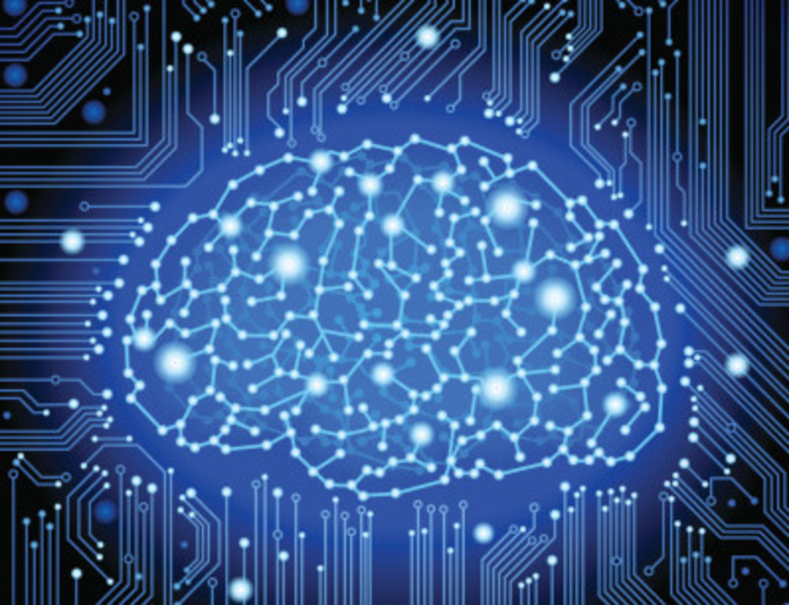
Fig: - 6.1 (Imaginable artificial circuitry)
Capabilities currently classified as AI include successfully understanding human speech, competing at a high level in strategic game systems (such as chess and Go), self-driving cars, intelligent routing in content delivery networks, and interpreting complex data.
AI research is divided into subfields that focus on specific problems, approaches, the use of a particular tool, or towards satisfying particular applications.
This raises philosophical arguments about the nature of the mind and the ethics of creating artificial beings endowed with human-like intelligence, issues which have been explored by myth, fiction and philosophy since antiquity. Some people also consider AI a danger to humanity if it progresses unabatedly. Attempts to create artificial intelligence have experienced many setbacks, including the ALPAC report of 1966, the abandonment of perceptron’s in 1970, the Light-hill Report of 1973, the second AI winter 1987–1993 and the collapse of the Lisp machine market in 1987.
In the twenty-first century, AI techniques, both hard (using a symbolic approach) and soft (sub-symbolic), have experienced a resurgence following concurrent advances in computer power, sizes of training sets, and theoretical understanding, and AI techniques have become an essential part of the technology industry, helping to solve many challenging problems in computer science. Recent advancements in AI, and specifically in machine learning, have contributed to the growth of Autonomous Things such as drones and self-driving cars, becoming the main driver of innovation in the automotive industry.
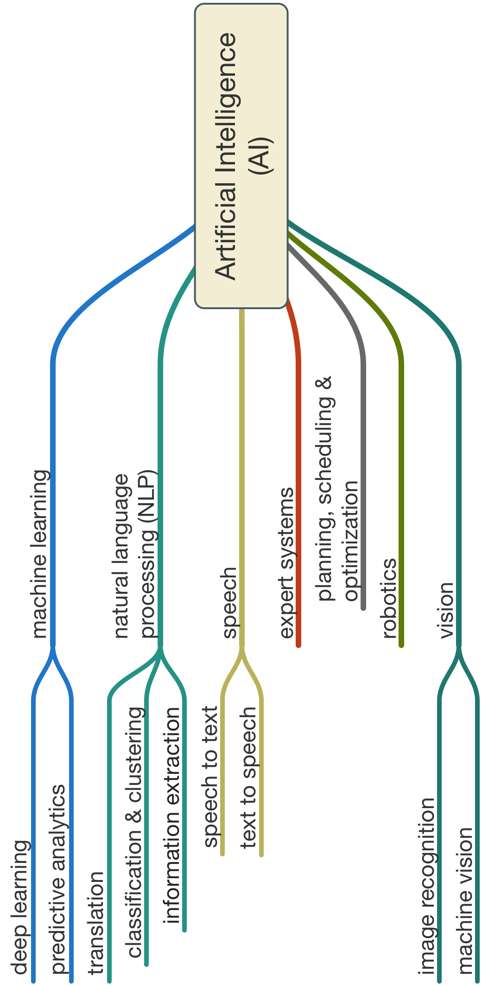
Fig: - 6.2 (Artificial Intelligence)

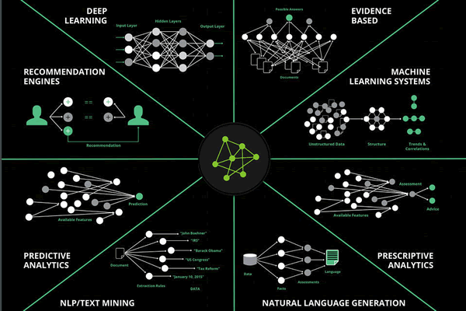

Fig: - 6.3 (Deep Phase of Artificial Intelligence)

In future the scientist are planning to introduce fifth generation humanoid robots which will have their own artificial intelligence enabling them to perform the various task & functions without taking any commands & instructions, it can sense the situations & to carryout response according to it. Though it will be amazing but some people are a bit apprehensive of its evolution, according to them what if it went rouge of if its intelligence can be hacked by some anti-social groups etc. to cause destructions, it can be a danger but if proper security protocols are installed then this threat can be eliminated because the robots are design to follow four basic LAWS OF ROBOTS as described in the introduction parts Chapter 1 section no. 1.5. In the end all we can speculate that this is an amazing discovery & the future holds great many formidable & exquisite things for robots as they can execute various endeavors which are not beyond conceiving for human force & intelligence, their strength & speed makes them more reliable & efficient to perform all the functions in a perfect manner.

